SEMANTIC NETWORKS
    - A semantic network is a structure for representing knowledge as a pattern of interconnected nodes and arcs. Nodes in the net represent concepts of entities, attributes, events, values. Arcs in the network represent relationships that hold between the concepts.
    - A semantic network is a graph theoretic data structure whose nodes represent word senses and whose arcs express semantic relationships between these word senses.
    - Concepts can be represented as hierarchies of inter- connected concept nodes
(e.g. animal, bird, canary)
    - Any concept has a number of associated attributes at a given level (e.g. animal –> has skin; eats etc.)
    - Some concept nodes are super class of other nodes (e.g. animal > bird) and some are sub classes (canary < bird)
    - Often, sub classes inherit all the attributes of their super class concepts.
    - Some instances of a concept are exempted from the having certain attributes held by their concept classes (e.g. ostrich is excepted from flying)
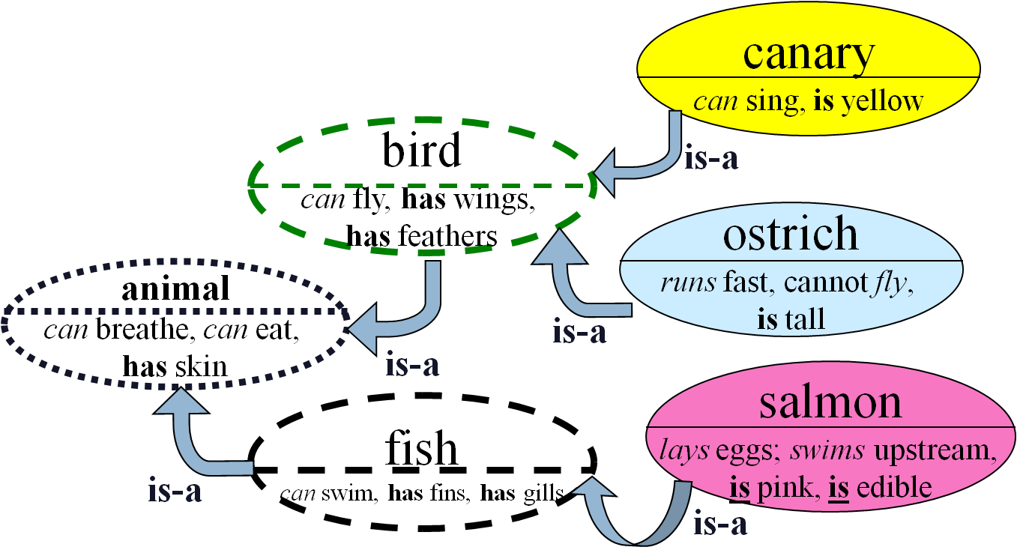
4.0.2. Advantages of Semantic Networks
- Advantages
- Easy to visualise and understand.
- The knowledge engineer can arbitrarily define the relationships.
- Related knowledge is easily categorised.
- Efficient in space requirements.
- Node objects represented only once.
- Standard definitions of semantic networks have been developed.
- Disadvantages of Semantic Networks
Limitations
- The limitations of conventional semantic networks were studied extensively by a number of workers in AI.
- Many believe that the basic notion is a powerful one and has to be complemented by, for example, logic to improve the notion’s expressive power and robustness.
- Others believe that the notion of semantic networks can be improved by incorporating reasoning used to describe events.
- Limited in handling quantifiers e.g. “Every dog has bitten a postman”
- Binary relations are usually easy to represent, but some times is difficult.e.g. try to represent the sentence: “Nengo caused trouble to the party".
4.1. Frames
These are knowledge representation formalisms in which stereotyped information on objects are represented.
Features:
- capture object attributes and their values;
- search done by matching; Structure:
- Node and collection of attributes(slots).
4.1.1. Advantages:
- can cope with missing values- close matches are presented.
4.1.2. Disadvantages:
- has been hard to implement, especially inheritance.
Example . Try to represent the following two sentences into the appropriate semantic network diagram: isa(person, mammal) instance(Duggan Kariuki, person) all in one graph team(Duggan Kariuki, Cardiff) score(Gor Mahia, AFC, 1-3) Misiko gave Ngicu the book
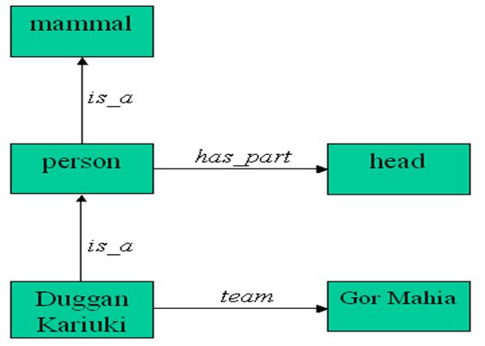
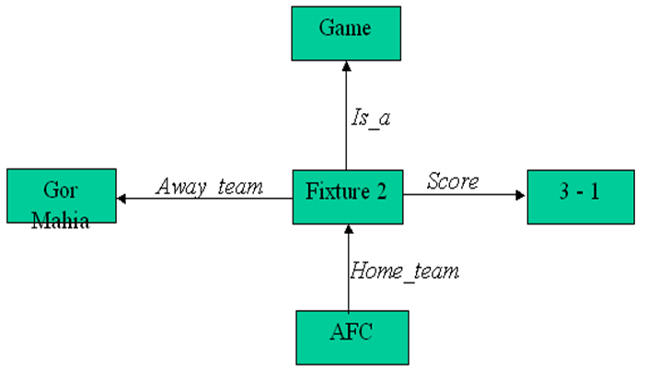
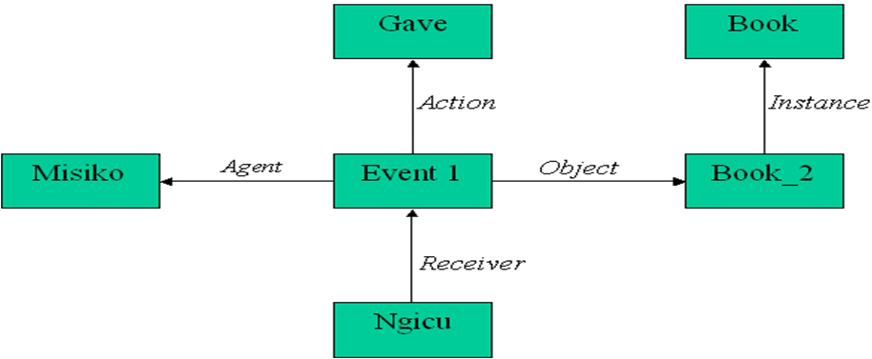
    - Discrimination function
Discrimination function is a function that maps input features into a classification space.
•.1. They are used in many pattern recognition techniques.
    - Classification techniques
There are two broad classes of classification techniques. These are
- numeric and
- non-numeric methods.
•.2. The numeric methods are classification techniques that use measurements of geometric patterns.
•.3. They can be deterministic or statistical.
•.4. The non- numeric methods are classification techniques that that depend on symbolic processing such as those dealing with fuzzy sets.
•.5. Our scope of treatment will only cover numeric-methods of classification include deterministic and statistical techniques
- k-NEAREST NEIGHBOUR CLASSIFICATION: The nearest neighbour classification is one in which a new pattern is placed in the class to which it is closest.
- Hamming distance
- Euclidean distance
- City-block distance
- Square distance
Revision questions
Example . what is a semantic network? give its a advantages and disadvantages
Solution:
Advantages.
Easy to translate to predicate calculus.
Disadvantages.
Cannot handle quantifiers; nodes may have confusing roles or meanings; searching may lead to combinatorial explosion; cannot express standard logical connectives; can represent only binary or unary predicates.

EXERCISE 4. Describe blind search.
EXERCISE 5. Describe guided search.
EXERCISE 6. Describe the knowledge representation formalisms giving their advantages and disadvantages.
EXERCISE 7. Learning Activities What is pattern recognition?
What is classification?
Explain the meanings of the terms feature vector and feature space.
What is discrimination function?
Describe the nearest-neighbour classification technique.

